Toppers (2024-2025)

B.sc 5th Sem
Students Name | Father’s Name | Class | Class Roll No. | Marks  % | Position | Mobile  No. | Picture
Loveleen | Sh. Kashmir Singh | B.Sc Medical | 1221963030014 | 270/320 | 7th | 9053135318 | 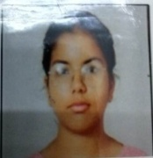
Preeti | Sh. Suresh Kumar | B.Sc Medical | 1221963030008 | 269/320 | 8th | 9992889779 | 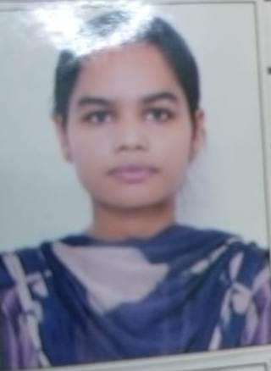
Prerna | Sh. Ramparshad | B.Sc Medical | 1221963030010 | 265/320 | 10th | 8708000167 | 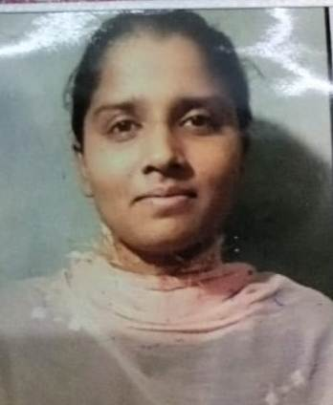
Muskan | Sh. Bajinder Singh | B.Sc Non. Medical | 1221963015012 | 325/370 | 2nd | 9416308548 | 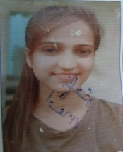
Muskaan | Sh. Naresh | B.Sc Non. Medical | 1221963015003 | 301/370 | 9th | 8813831355 | 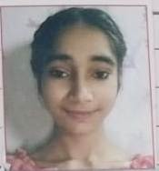
Khusbhu | Sh. Sukhdev | B.sc Computer Sc. | 1221963015039 | 300/350 | 2nd | 8708194467 | 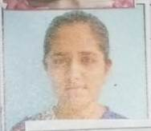

B.sc 6th Sem
Students Name | Father’s Name | Class | Class Roll No. | Marks  % | Position | Mobile  No. | Picture
Khusbhu | Sh. Sukhdev | B.sc Computer Sc. | 1221963015039 | 2501/2900  86.24 | 1st | 8708194467
Loveleen | Sh. Kashmir Singh | B.Sc Medical | 1221963030014 | 2546/2900  87.79 | 2nd | 9053135318
Muskaan | Sh. Naresh | B.Sc Non. Medical | 1221963015003 | 2564/2900  88.41 | 2nd | 8813831355
Kafi | Rohtash | B.sc 3rd Sem (Med) | 1221963030023 | 2519/2900 86.86% | 4th | 8572830278 | 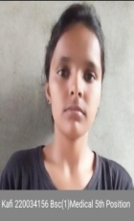
Preeti | Sh. Suresh Kumar | B.Sc Medical | 1221963030008 | 2481/2900  85.55 | 8th | 9992889779
Muskan | Sh. Bajinder Singh | B.Sc Non. Medical | 1221963015012 | 2447/2900  84.37 | 9th | 9416308548

B.Com 5th Sem
Students Name | Father’s Name | Class | Class Roll No. | Marks  % | Position | Mobile  No. | Picture
Preeti | Mr. Ram Niwas | B.Com 5th Sem | 1221963003022 | 486/600  81% | 9th | 9812763509 | 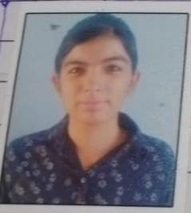

B.Com 6th Sem
Students Name | Father’s Name | Class | Class Roll No. | Marks  % | Position | Mobile  No. | Picture
Preeti | Mr. Ram Niwas | B.Com 5th Sem | 1221963003022 | 2897/3600  80.47% | 5th | 9812763509
Saloni | Sh. Neeraj Gupta | B.com 4th Sem | 1221963003006 | 2906/3600  80.72 | 3rd | 9416384945 | 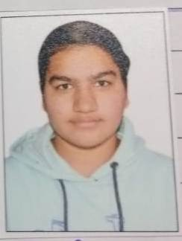

M.sc Math 3rd Sem
Students Name | Father’s Name | Class | Class Roll No. | Marks  % | Position | Mobile  No. | Picture
Anju | Sh. Rajesh | M.Sc Math | 2231928013 | 530/600 | 1st | 8950407148 | 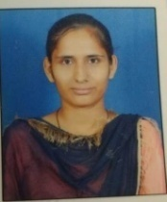
Aastha | Sh. Ranbir Singh | M.Sc Math | 2231928006 | 524/600 | 2nd | 8930358144 | 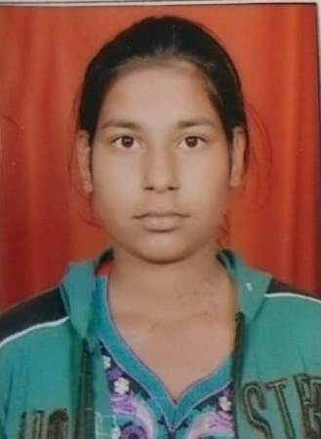
Annu | Sh. Dilbag | M.Sc Math | 2231928007 | 516/600 | 4th | 7206838103 | 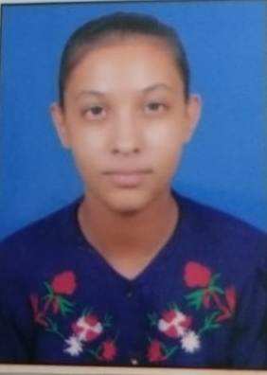

M.sc Math 4th Sem
Students Name | Father’s Name | Class | Class Roll No. | Marks  % | Position | Mobile  No. | Picture
Anju | Sh. Rajesh | M.Sc Math | 2231928013 | 482/600 | 1st | 8950407148
Pooja Rani | Sh. Atma Singh | M.sc Math | 2231928009 | 445/600 | 6th | 9350729270 | 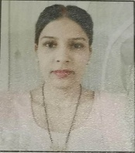

MA ECO 3rd Sem

Students Name | Father’s Name | Class | Class Roll No. | Marks  % | Position | Mobile  No. | Picture
Komal | Krishan | MA Eco 3rd Sem | 130215611 | 383/500  76.6% | 5th | 8607412875 | 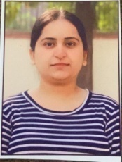
Sheetal | Mr. Jogi Ram | MA Eco 3rd Sem | 130215606 | 369/500  73.8 % | 10th | 8950707020 | 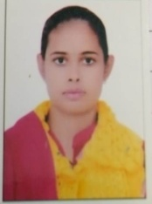
Sonali | Jai Parkash | MA Eco 3rd Sem | 130215620 | 379/500 75.8 % | 8th | 8295861476 | 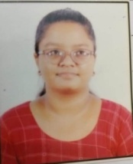

MA ECO 4th Sem

Students Name | Father’s Name | Class | Class Roll No. | Marks  % | Position | Mobile  No. | Picture
Komal | Krishan | MA Eco 4th Sem | 130215611 | 1483/2000  74.15% | ^{10th} | 8607412875
Sheetal | Mr. Jogi Ram | MA Eco 4th Sem | 130215606 | 1531/2000  76.55 % | 5th | 8950707020
Sonali | Jai Parkash | MA Eco 4th Sem | 130215620 | 1501/2000 75.05 % | 9th | 8295861476

M.COM 4th Sem

Students Name | Father’s Name | Class | Class Roll No. | Marks  % | Position | Mobile  No. | Picture
Shobha | Sh. Subhas | M.com 4th Sem | 2231927024 | 1980/2500  79.2% | 9th | 7027962310 | 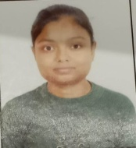

B.A 6th Sem
Students Name | Father’s Name | Class | Class Roll No. | Marks  % | Position | Mobile  No. | Picture
Sohni | Umed Singh | B.A 6th Sem | 220059287 | 411/450  91.33% | 1st | 8930215597 | 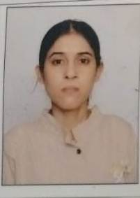
Mahak | Sushil Kumar | B.A 6th Sem | 220059214 | 334/370  90.27 % | 2nd | 9306217297 | 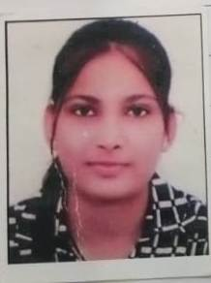
Himanshi | Baljeet Singh | B.A 6th Sem | 220059205 | 388/430  90.23% | 3rd | 7988132372 | 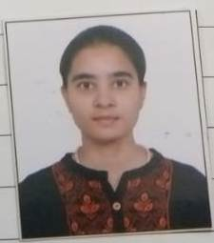
Muskan Rani | Mohan Singh | B.A 6th Sem | 220059130 | 381/430  88.60% | 6th | 8901957010 | 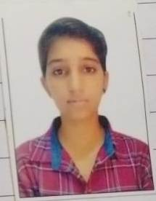
Neha | Sataywan | B.A 6th Sem | 220059437 | 351/400  87.75% | 9th | 9416782503 | 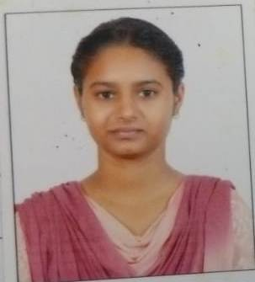
Tamanna | Mohinder Singh | B.A 6th Sem | 220058512 | 351/400  87.75% | 9th | 9350252012 | 