The rapid urbanization and economic development at local, regional and global level has led to several environmental and ecological crises. On this background it becomes essential to adopt the system of the Green Campus for the institute which will lead for sustainable development. I.G.(P.G.)M.M.V. , KAITHAL is deeply concerned and unconditionally believes that there is an urgent need to address these fundamental problems and reverse the trends. The purpose of the audit was to ensure that the practices followed in the campus are in accordance with the Green Policy & Energy Policy adopted by the institution. It works on the several facets of ‘Green Campus’ including Water Conservation, Tree Plantation, Waste Management and Paperless Work. With this in mind, the specific objectives of the audit was to evaluate the adequacy of the management control framework of environment sustainability as well as the degree to which the Departments are in compliance with the applicable regulations, policies and standards.

Sr. No. | ACTIVITY PERFORMED | TOPIC | ORGANIZED BY | OUTCOMES | PICS
1. | Tree plantation | Green Environment | Geography Dept. | On 5 June,2022, 120 saplings were planted by the students in the college campus on World Environment Day | 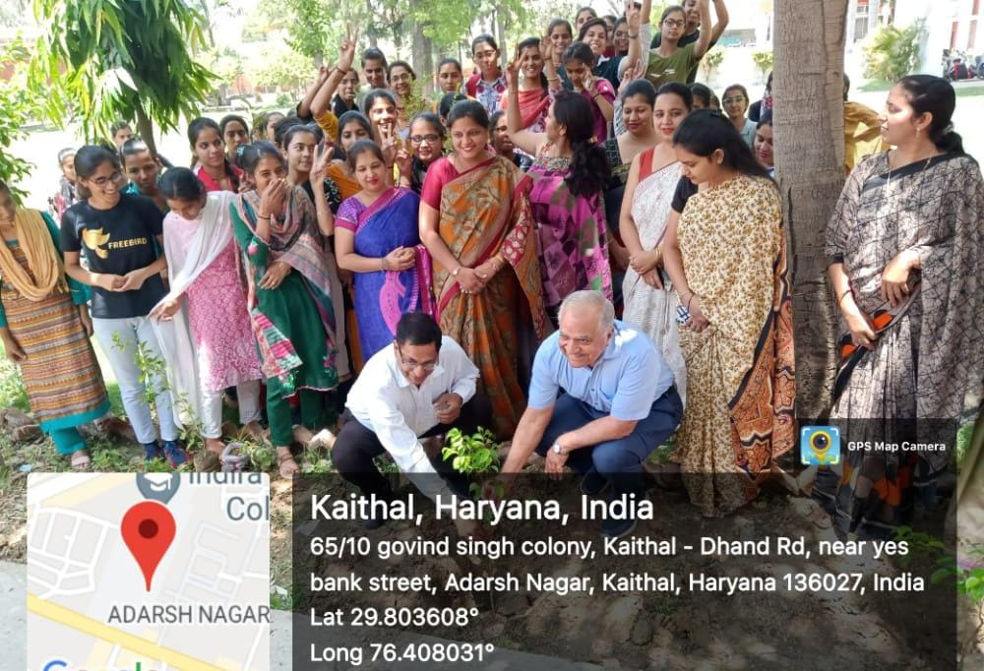
2. | Declamation and presentation competition | Conservation of Earth | Science Dept. in collaboration with Geography Dept. | Students of our college participated in Declamation and poster presentation competition on 22 April,2022 on Earth day followed by taking oath so as to conserve earth by reusing, recycling the wastes and taking appropriate methods for conservation of earth.
3. | Tree Plantation | Green Environment | N.S.S | Under NSS, a seven day and night camp was organized from 23 March,2022 to 30 March,2022. During this camp, girls planted trees in college campus and students were motivated to keep environment clean and use eco-friendly products. Girls ran clean environment program and visited the village Shergarh and gave door to door information to aware the people about clean environment | 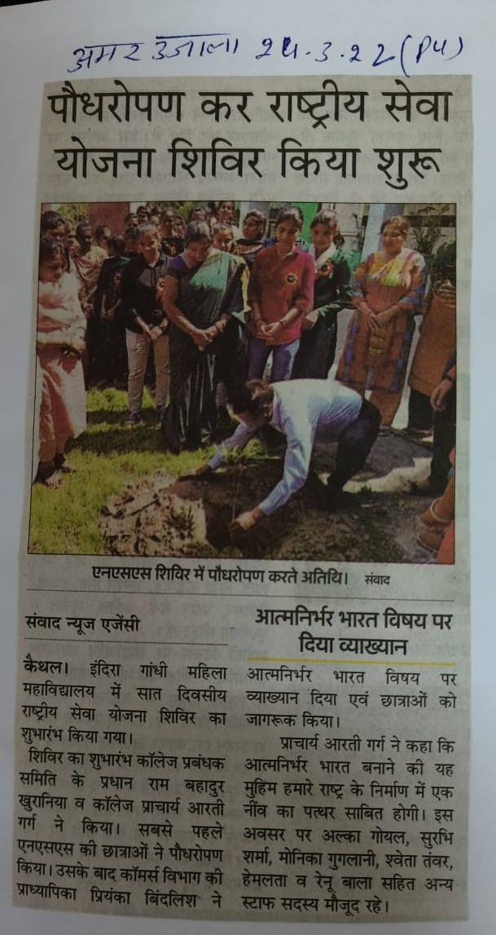
4. | Rally and Painting Competition | Pollution arising due to burning of Stubbles | N.S.S. | N.S.S. Units organized An awareness Rally to aware the students and people about the increasing environmental pollution and after effects due to burning of stubbles and paddy crops. | 